|  |
| --- |
| University of Maryland – college park |
| Capstone Project – Designing a touch screen application to help young children develop programming skills |
|  |
|  |
| **Author: Panagis Papadatos. Advisors: Mona Leigh Guha, Tamara Clegg** |
| **Class: INST776 – HCIM Capstone, Class Advisor: Leah Findlater, Spring 2013** |

|  |
| --- |
| Abstract: Acquiring skills that are fundamental to programming early on in one’s life is a valuable skill. Not only does it help with the development of basic logic skills, but it also encourages children to learn more about computer science and understand technology at a more fundamental level. The goal of this capstone project was to design and develop an iPad application that would scaffold young children (3-5 years old) in developing skills that will later support them in programming. In attempting to achieve this goal, we conducted research with children and expert child educators, while aiming to develop guidelines for developing the application on a touch screen device. |

**Capstone Project – Designing a touch screen application to help young children develop programming skills**

Panagis Papadatos, Advisors: Tamara Clegg, Mona Leigh Guha

Table of Contents

1 Thesis Statement 2

2 Abstract 2

3 Introduction 2

4 Background 3

4.1 Limitations of the field 6

5 Description of the Product 6

5.1 Interface 6

5.2 Related Concepts 7

5.3 Level Progression 8

5.4 Instructions 14

5.5 Connection to the concepts being learned 15

6 Design and Evaluation 15

6.1 Summary of the methods used 15

6.2 How the literature informed the design 16

6.3 Kidsteam 16

6.4 Design Session 1: Robot activity & drawing of iPad application 16

6.5 Kidsteam Design Session 2: Layered elaboration 18

6.6 Formative evaluation with experts (Teachers) 20

6.7 Formative Evaluation with young children 23

7 Discussion 25

8 Limitations 26

9 Future Work 26

10 Conclusion 27

11 Acknowledgements 27

12 References 28

13 Appendix - Design 1 30

14 Appendix - Design 2 31

# Thesis Statement

The iPad application that was designed and built during this capstone intends to help young children learn skills that are integral to programming.

# Abstract

Acquiring skills that are fundamental to programming early on in one’s life is a valuable skill. Not only does it help with the development of basic logic skills, but it also encourages children to learn more about computer science and understand technology at a more fundamental level. The goal of this capstone project was to design and develop an iPad application that would scaffold young children (3-5 years old) in developing skills that will later support them in programming. In attempting to achieve this goal, we conducted research with children and expert educators, while aiming to develop guidelines for developing the application on a touch screen device.

# Introduction

Very young children are often left out of consideration in Computer Science learning. However, learning these skills early on is possible and extremely beneficial [1, 2, 3]. Our contribution to the field of Human Computer Interaction is a touch screen application that helps young children (ages 3-5) be ready to face a world that requires thinking like a programmer. Mobile touch screen technologies are currently dominating our lives, and especially the lives of children, especially since they provide a more fluid and pleasurable experience compared to most other types of interfaces. The objective of this project was to design and implement a touch screen application that will help young children learn skills that are integral to programming. This application will also help children in developing computational thinking (CT) skills, which are widely considered to be a valuable asset [4, 5]. Furthermore, the process of designing this application provides a foundation for other designers and perhaps knowledge useful for researchers trying to create similar products or study similar subjects.

A plethora of factors led us to work on this problem. First and foremost, the comfort of younger generations with computers has made children more independent of their parents in their exploration processes, which suggests a greater learning need [2]. By giving children the tools to build their own interactive environments, they can experience a level of creative autonomy previously limited to adults [2]. Furthermore, acquiring debugging skill sets enhances the development of logical thinking, problem articulation, team working, persistency, problem solving, and social interaction skills [6]. Finally, providing reading opportunities to young children is important during an important time period in their development of reading skill and comprehension [5].

Our motivation was also drawn from a different perspective; both the study of Computer Science (CS) and its related industries have recognized the importance of fostering the development of CT and skills earlier in students’ education [7]. This is especially true in light of current market conditions, where there is huge demand for computer scientists and an intense lack of diversity amongst its practitioners. More specifically, many students never investigate computer science as an academic option, because they have not been sufficiently exposed to computer science or because they feel that their identities do not match well with the stereotype of programmers [8, 9]. The latter is particularly true for African American populations, Latino populations and women [9]. These problems could be tackled by educating people from a younger age, thus encouraging them to be more interested in CS [10, 11, 12, 13].

Before beginning our research, we established that computer programming and CT are age appropriate materials for preschoolers. Research shows that children have the ability to control their interactive environments and that ability is stronger in the modern era [2]. Computer programming is a developmentally appropriate practice in preschools [14] since children are able to learn aspects of programming by performing specific tasks and can reason logically as long as principles are applied to concrete examples [15]. Most importantly, preschoolers enjoy programming-like activities and have the desire to do perform them; this desire is strengthened when the environment allows for the ability to create dynamic and interactive worlds or games [16].

# Background

Two different types of research proved valuable to the process of conducting our research and developing our application. The first type [17, 18, 19, 20, 21], past attempts to help young children learn concepts related to Computer Science helped define the space in the field where our application would fit and determine what types of concepts there are to be learned. They also taught us useful lessons, not only about how to conduct the research, but also about how to design the application and its interactions. The second type of research, concerned with designing touch screen and mobile applications for children [22, 23, 24], provided useful guidelines and lessons that helped us determine the structure of the application. The research also posited types of interactions that are most appropriate, as well as the types of feedback and instructions required. Researchers have often attempted to scaffold the learning of programming and CT concepts [25, 26, 2, 7, 1]; therefore, the literature provides necessary insight into challenges, design ideas and suggestions that proved valuable in understanding the field and expanding it.

In the past 10 years, there have been several attempts to create games, or otherwise educational environments that encourage children to acquire CT skills. The most famous example is Logo [7], a mostly graphic computer programming language developed in 1967 that has been employed and adapted multiple times [5]. Logo, despite being used in a wide variety of computer science learning for young children, does not take advantage of modern research regarding mobile and web technologies, which are currently the most commonly used technologies [22]. This fact is limiting, since designing for such technologies needs to take into account multiple factors that are irrelevant to desktop or offline technologies, especially in regards to children [22]. However, Logo and attempts that followed taught us that programming is a topic that is appropriate for children. They also showed that allowing the children to independently understand programming concepts is doable and beneficial, while providing insight on the advantages and disadvantages of different approaches and expanding on the theoretical foundations.

Researchers have also employed different techniques with widely different goals and target groups. Some authors [9, 17, 18, 19], for instance, demonstrated how programming by example works and suggests animating concepts. They posited that understanding how a program works can be achieved more easily through concrete examples of how it is being used as opposed to focusing on the rules. Furthermore, they all stressed that designing such software for people with no experience is fundamentally different and they explained that real life metaphors are valuable as a tool to explain CT concepts. Last, they suggested helping users make an extra logical step to proceed in their learning process when they are having trouble.

Another example would be the software Creator (Smith et al. [21]), which uses programming by demonstration to encourage program construction and targets children around the age of 12. Smith et al. brought to our attention the value of removing details to understand a concept and provided thoughts on what types of details are better to remove. They also suggest using animations as a learning tool and analogs as a way to introduce concepts.

Magic Words [26], is a behavior-based visual programming toolkit that allows children (close to 5 years old) to create their own interactive worlds and games. Similarly, Toontalk [9, 26] is an animated and action-based programming language that has been tested with preschoolers and which also focuses on the removal of unnecessary conceptual details. Alice [13] is a 3D programming environment that allows children to create narratives, play games and create videos; Alice, through its narratives, proved to have motivated middle-school children to be more interested in the field of Computer Science.

Kindborg and Sökjer [26] instrumented a different learning methodology, one with uses behavior-based programming. They stressed that demonstrating high level behaviors first is beneficial to learning, especially when algorithmic detail is abstracted. Another popular software, Scratch [20], is a visual programming environment that allows users (primarily ages 8 to 16) to learn computer programming while working on personally meaningful projects such as animated stories and games. One interesting takeaway from Scratch is that its success could be attributed to the fact that it was designed with a focus in simplicity and self-directed learning.

Fizz (Sheehan and Cho [4]) is a physics-based programming system (ages 6 to 12) that allows the production of games and simulations using events and drag and drop programming. Sheehan and Cho concluded that multiple levels are required for each concept in order for sufficient understanding to be achieved. CTArcade [5] allows learners to train their own virtual characters while playing games with it. CTArcade was designed around the idea that starting with natural human pursuits and connecting CT concepts to them is beneficial to the learning. Overall, these examples provided us with interesting ideas and methods of modelling programming concepts. This input affected the design of our application, which borrowed positive elements from most of them.

Many of the activities that were studied used a different perspective on this topic, that of “physical programming”: The Robo-Blocks system [6], which is focused around elaborating on the concept of debugging, allows children to connect physical command blocks (ages 8-9). Electronic Blocks [14, 27, 28] is another physical programming environment. It is designed specifically for children aged between 3 and 8 years and it takes advantage of its physical affordances to enhance the learning.

Storyroom [2] uses a set of tangible tools and metaphors in a room sized environment that allows for children as young as 4-6 to benefit from it. As in most of the examples mentioned earlier, Storyroom attempted to help children be independent in their learning. The above research suggests that physical interactions admittedly have qualities that are beneficial to scaffolding the learning; we believe that the iPad, a device whose interface and interactions are physical by nature, would provide affordances similar to those mentioned in the above research.

Some researchers were focused on providing guidelines and examining proper ways of conveying this type of information; their conclusions and guidelines provided valuable insights concerning the design of this application. More specifically, Lee et al. [5] stressed that it is important to aid learners in thinking in an abstract and generalized way while trying to minimize the effect of split attention. Conversely, Lin and Liu [1] provided guidelines on child-parent collaboration and demonstrated the positive and negative effects of the parental involvement in the learning process. Lin and Liu suggested activities that divide the roles of reviewer and driver between the parent and child; given that both parent and child could assume either role. One of the papers that were most closely related to our research, written by Morgado et al., [3] addressed several issues that related to ways of teaching programming to preschoolers through software and summarized the research and crucial points to be considered. Finally, Sipitakiat and Nusen [6] provided different manners of demonstrating and learning debugging concepts, while proving that they are developmentally appropriate. Wyeth and Purchase [28] suggested design criteria for activities that encourage the learning of CT, while connecting early childhood development principles to the learning methods. They suggest letting children design and construct their own programming/CT related activities in order to enhance their engagement and learning processes.

Regarding the design of touch screen technology for children, McKnight and Fitton [23] provided guidelines on the terminology that needs to be used when giving instructions to young children in regards to touch screens. For example, they suggest not using terms like scroll or drag, but simpler terms like touch or move, and they provide elaborate guidelines on how to use certain terms. Further, they provide guidelines for the interaction methods i.e., do not expect children to double tap or tap and hold. These guidelines proved extremely useful to this project and affected every iteration of the design process because the provided an initial research-validated base for the interactions of the application. Similarly, Revelle and Reardon [24] provided an elaborate set of guidelines for designing touch screen applications for young children. Most notably, they mention including a variety of audio prompts, large distinct hotspots and teaching new interactions through simplified trials. Sheehan et al. [4] suggested ways in which to take advantage of physics laws which are intuitive to children. Lastly, Kindborg and Sökjer suggested the use of voice and text for instructions while Druin et al. [22] provided an extensive list of challenges, guidelines, and ideas that relate to designing mobile learning technology for children.

## Limitations of the field

Though a wealth of research exists on teaching CT to children, a large percentage of it is often about older children. Since young children grow and change with a rapid pace, different software exists for different age groups, and knowledge about older children cannot directly be applied to younger children. As an example, Druin [22] mentioned that portable device applications are categorized into 11 separate age groups for ranging from 0 to 15. Furthermore, to this date, we could only find one product that attempted to help young children learn programming skills through the use of touch screens: Move the Turtle [29] is an iPad application that targets children five and up; however, parents have criticized it for not being designed in a way that is age appropriate, since it includes too much text and no auditory instructions. This project attempts to expand the field in two ways: by developing such an application for children younger than 5 years old, and by examining the implications of implementing it on a touch screen.

# Description of the Product

We chose to implement this application on a mobile device, as mobile technology will soon be prevalent in classrooms, therefore the need for children to understand and use it is becoming more and more pressing [22, 23]. Not only are mobile devices an emerging trend, but they can also be highly motivating for children since they can be used in the wild, thus increasing the engagement level of children in their learning processes [5]. These points made it clear to us that it is beneficial to create a touch screen application that will allow young children to develop their CT skills. More specifically, we decided to make an iPad application, since the iPad is large enough to allow for more content to be displayed on the screen without it looking crowded and confusing the users, as opposed to a phone. We suspect that the slightly physical nature of touch screen devices like the iPad allows for an immersive experience [22]. The application was developed using XCode, Objective C, Phonegap, HTML, CSS, Javascript and the libraries jQuery and KineticJS.

The application is a game that consists of 5 levels (1 introductory and 4 progressive), a “Castle and Shop” and a “Replay Hall”. When the game starts, an animation appears with a robot and a dog and the players are introduced to a short narrative with the goal of the game, which is to guide “Clinky the Robot” to his plug so that he can charge. A live version of the game is currently available on a browser (Google Chrome) at <http://heypano.github.com/Capstone/>.

## Interface

The interface (Figure 5.2) consists of two panels: One square on the left where most of the interactions that relate to the game take place and one “control panel” to the right that provides information about the player’s status and allows for additional instructions or switching state to “Castle and Shop”, the “Replay Hall” or going back to the game if the game state is either of the latter.

Since some of these concepts are outside the range of what a 3-5 year old child can fathom, we attempted to design the application so that – for these concepts - it provides precursory knowledge that will assist their learning, so as to allow for a more fluid transition when they grow older. The concepts are introduced gradually in the game in order to reduce the learning curve.

## Related Concepts

In the process of creating this application, we sought to incorporate several concepts that are key to acquiring programming skills and developing CT. More specifically, elements from the following taxonomies were used:

Morgado et al. [3] provided the initial taxonomy for the design of the application:

1. Syntax and Semantics
2. Compound Procedures
3. Parameter Passing
4. Parallel/Concurrent Execution
5. Message Passing / Communication Channels
6. Input Guards
7. Clients and Servers

Of the above, the application attempts to assist the learning of 1, 2, 4 and 6. However, two more taxonomies were considered while designing the application, though not as strictly. Wyeth provides a taxonomy of programming topics [14]:

1. Syntax and functionality
2. Achieving specific outcomes through programming
3. Reusing parts
4. Debugging
5. Planning
6. How often children built and compared alternative solutions to programming tasks

Barr and Stephenson provide a useful list of CT skills [25]:

1. Design solutions to problems (using abstraction, automation, creating algorithms, data collection, and analysis)
2. Implement designs (programming as appropriate)
3. Test and debug
4. Model, run simulations, do systems analysis
5. Reﬂect on practice and communicating
6. Use the vocabulary
7. Recognize abstractions and move between levels of abstractions
8. Innovation, exploration, and creativity across disciplines
9. Group problem solving
10. Employ diverse learning strategies

Since some of these concepts are outside the range of what a 3-5 year old child can fathom, we attempted to design the application so that – for these concepts - it provides precursory knowledge that will assist their learning, so as to allow for a more fluid transition when they grow older. The concepts are introduced gradually in the game in order to reduce the learning curve.

## Level Progression

### Introductory Level

The goal of this level (Figure 5.1) is to help the children become familiar with the interactions found in the next levels, to introduce the idea of “programming,” and some basic concept of planning. When the starting animation is over, the narrator introduces the term “to program” and explains it in a simplified way. Next, the player is shown a robot and a plug and is prompted to draw a line to “show the robot the path”. The player needs to then put her finger on Clinky and draw a line that will determine the path that the robot will follow when she removes her finger from the screen. This portrays the concept of planning, given that the entire path needs to be drawn before the robot moves. If the robot does not reach the plug at the end of the path, it resets to its original position and the player can try again. When the robot hits the plug, it congratulates the player and moves on to the next level.

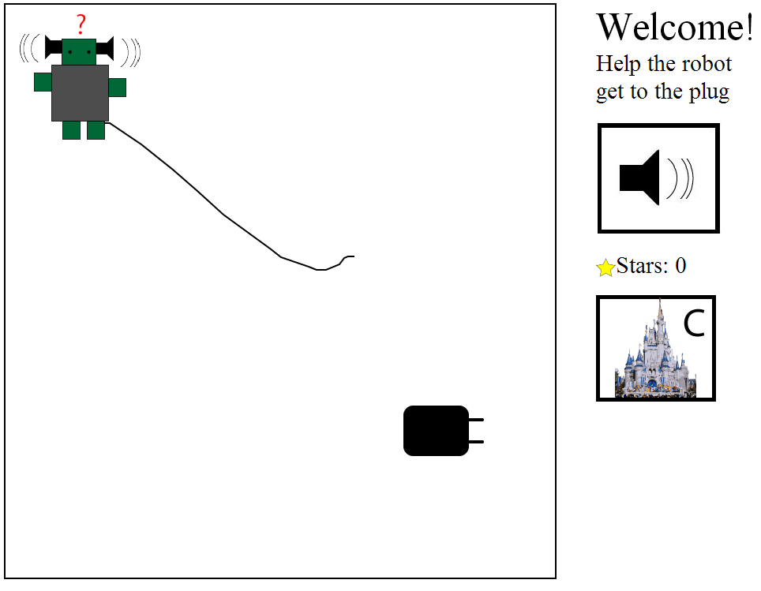

Figure . – Introductory Level

### Level 1

Level 1 (Figure 5.2) introduces a layer of complexity that expands on the same concept as the introductory level (planning) and to bring another programming term to the child’s attention. It also aims to demonstrate the reward system of the game (stars) and the “replay hall” which allows for the “re-execution” of programs. Level 1 begins with the narrator introducing the term “to execute”. It follows exactly the same mechanics as the introductory level, with two differences; there is a simple maze that the player needs to solve, and there are stars that are collected when the robot moves over them. Level 1 also introduces a new button that links players to the “Replay Hall”, which at this point allows for re-executing of the first program, i.e. it replays exactly what the player did in the introductory level.

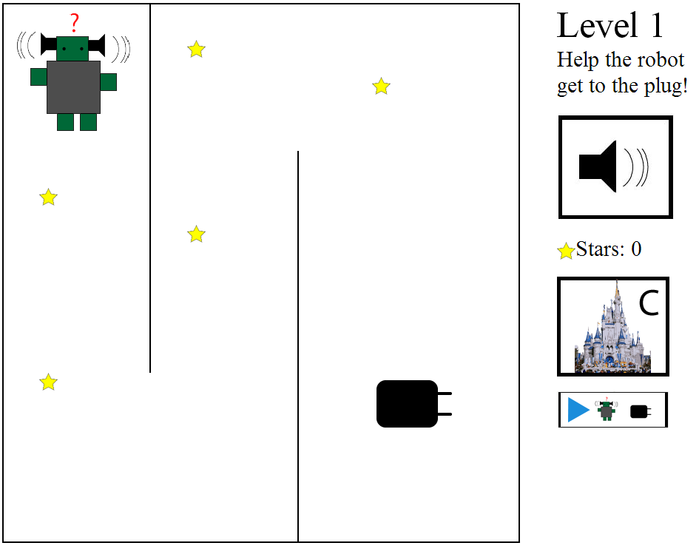

Figure . – Level 1

### Level 2

The goal of Level 2 (Figure 5.3) is to add a basic understanding of “debugging” on to the concepts established by the previous levels. The narrator introduces the concept of “debugging” by explaining the term in a simplified manner: “To debug means to find mistakes or problems and fix them”. Then Clinky informs the player that she has made a mistake, and asks for help debugging. After the player detects and corrects the mistake, the robot provides her with positive reinforcement. Afterwards the level continues in the same way as the previous ones.

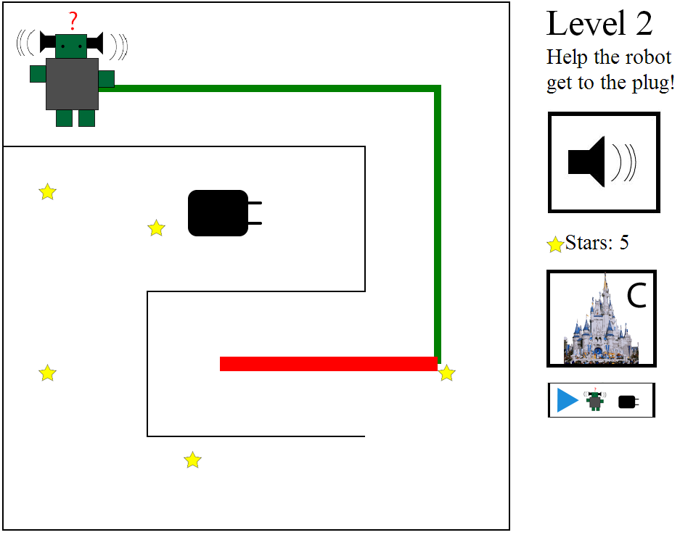

Figure . – Level 2 (Debugging)

### Level 3

The goal of Level 3 (Figure 5.4) is to introduce a basic understanding of the concept of “Parallel Execution”. Even though this is a complicated concept, working concurrently towards common or different goals -but within the same space- is something that directly connects to preschool education [3]. This level begins with the narrator stating that “To execute in parallel means to do something at the same time”. Then, Clinky explains that he noticed more programs running and asks for help executing his in parallel without getting in their way(i.e., draw a line to the plug without hitting the balls that are moving in a loop).

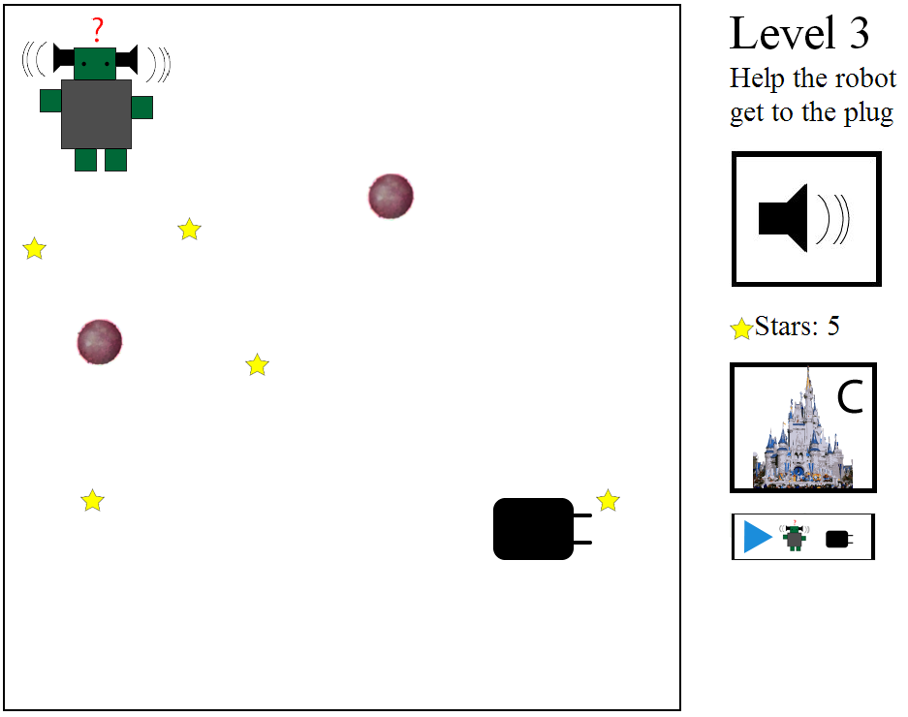

Figure . – Level 3 (Parallel Execution)

### Level 4

Level 4 (Figure 5.5) is the last and most advanced level of the game, as it introduces a “command list” that closely resembles an actual program. The goal of this level is to establish a more advanced understanding of the concept of planning, in combination with some rudimentary syntax and semantics. The player can no longer draw a path, but has to help Clinky traverse through a grid of various items by giving him a list of six commands. This new type of interaction is shown to the player at the beginning of this level, through an animated image showing a simulated interaction with a drawn hand. When the player touches one of the arrow buttons, the robot says “Execute command X”, where X is either left, right, up, or down.

Once the list has exactly six commands, Clinky executes them. Clinky will either go where the current instruction dictates, or state “I can’t go that way”. The command that is currently being executed is highlighted in yellow and once the robot reaches an item in the grid, it makes a sound (e.g. cat makes a meowing sound). If the robot has not reached the plug by the end of the execution, it resets and the player can start with a new set of commands. Once the robot reaches the plug, the player is given the title of “real programmer”, is rewarded 15 stars and is redirected to the replay hall to execute all 5 programs that she wrote.

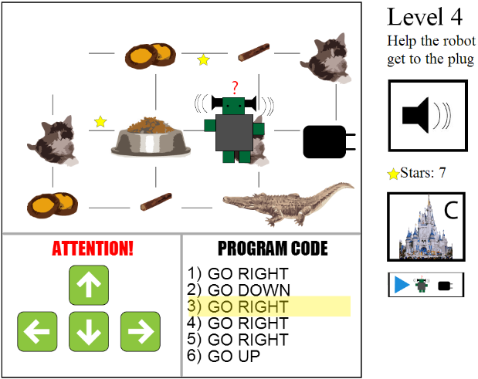

Figure . – Level 4 (Final)

### The Castle

The goal of The Castle (Figure 5.6) is to motivate the children to play the game, by providing a reward system to customize their character and gain a sense of ownership. This is achieved through two types of customization: changing the appearance and accessories of the robot and upgrading the castle; if the robot is customized, it changes form not only in the castle, but also throughout all of the levels and in the replay hall. The Castle is available at any stage of the game but each upgrade costs three stars, so the children might not be able to perform any actions here if they do not have enough.

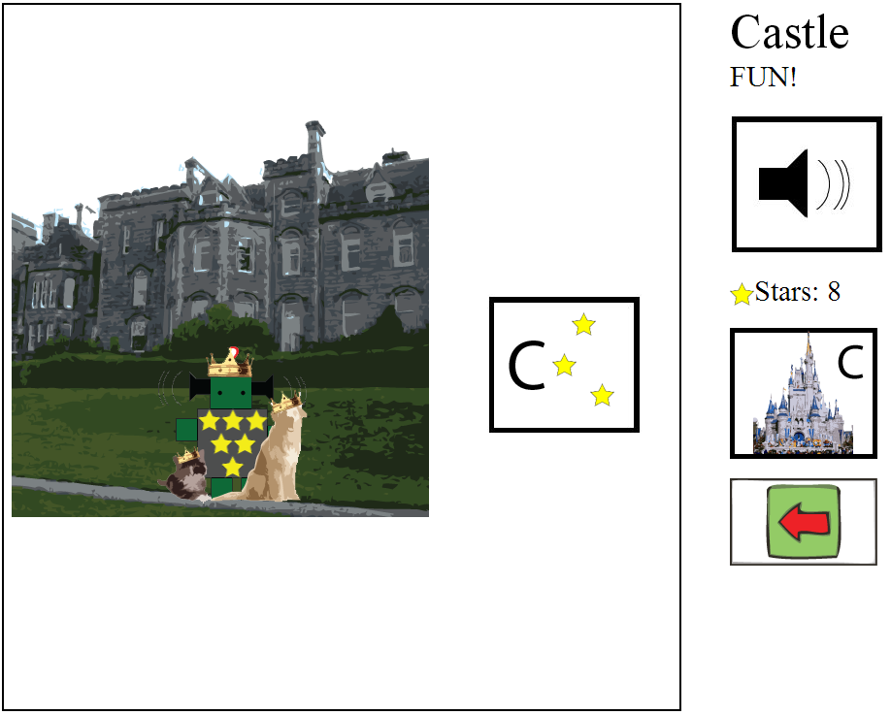

Figure . – The Castle

### Replay Hall

The “Replay Hall” (Figure 5.7) is a space that is available to players after they complete the introductory level, and it allows them to re-execute programs. Through executing the levels separately, this function aims to clarify the concept of a “compound procedure” or a “standalone program” with the aid of the terminology (to run a program, to execute) used in the auditory instructions. The concept of a “compound procedure” describes combined operations that can be described as a higher level unit that completes a function of its own (and could in turn be used by an even higher level logic structure). In terms of preschool education, this describes the idea that “doing one thing” can consist of “doing multiple smaller things”, while the former can be described and named as a whole [3]. In this instance, each compound procedure would be “completing a level” and it is comprised by the individual instructions (go left, then go right, avoid the wall, get the star etc.).

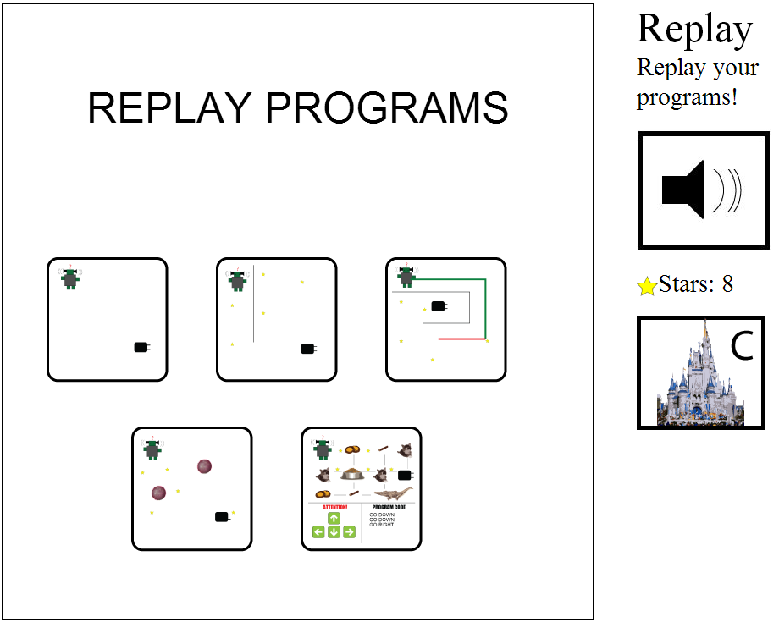

Figure . – Replay Hall

## Instructions

As suggested by Ravelle and Reardon [24], there are three types of repeated instructions throughout the game, Auditory, Visual and Textual. More specifically, the auditory instructions are split into 2 categories: narrator instructions - which are triggered either by starting a new level or by clicking the speaker button, and robot instructions – which are triggered as a reaction or when a new level starts. Different voices are used for the narrator and robot to make the instructions from Clinky feel more personal. For example, the programming vocabulary, which is used to enhance the learning, is introduced by the narrator, whereas reactions to game events use the robot voice. Visual instructions are provided in the form of an animated image that appears after multiple times of failure or before a new type of interaction is introduced (level 4). In this way, if a child is unsuccessful at using the application, a simulated scenario is shown, where a hand is performing the task required for the specific level. Textual instructions are only used sparsely so as to provide for reading opportunities and it is never expected that the player will read them therefore they provide no additional information.

## Connection to the concepts being learned

One basic concept of programming is that it consists of writing “chunks” of instructions that are executed and are preceded by planning [30]. Contrary to controlling machines in a conventional way, programming requires the entire list of instructions and possibilities (an algorithm) to be predetermined before the execution begins. For the first 4 levels, the entire path that the robot will take is defined before the robot starts moving. In the last level, this concept is conveyed in its most elaborate form, since a written list of instructions with set syntax is given and written down before the robot starts moving, which closely simulates real-life programming. Another concept that is consistently present throughout all of the levels is that the program code (instructions) is given to the computer as a whole before it starts executing. This differs slightly from conventional problem solving, where each sub-problem can be solved sequentially (planning is required) [30]. This idea is conveyed through the inability to interact with the system while the robot is moving (which includes not being able to change the path). Furthermore, puzzle solving, a developmental precursor to CT, is part of all the levels as well. Last, in terms of programming vocabulary, the first four levels introduce and use four programming terms, one at a time: “to program”, “to execute”, “to debug” and to execute “in parallel”.

As mentioned earlier, some programming concepts are also directly included in the game: Level 2 introduces the concept of debugging, Level 3 introduces the concept of parallel execution while Level 4 attempts to help the players gain a basic understanding of Syntax and Semantics, through written instructions that follow a specific “grammar”, and buttons that correspond to specific commands.

# Design and Evaluation

## Summary of the methods used

An iterative process was used for the design of the application, to allow for major changes to be made based on the various types of input acquired. All of the methods used followed formative research techniques given that the product would not be finalized at the end of our research. During the iterative design phase, we mainly used participatory design with slightly older children (ages 7-11) in two separate sessions. This provided a chance for different aspects of the design to be examined and it included children whose age is not exceedingly older than our target group but old enough to provide us with useful insights. Hence, they were able to provide us with valuable input regarding “what they would have wanted a few years ago” or “what would their younger sibling want”.

A great amount of the knowledge mentioned in the related research section of this proposal was also used, not only to improve the interactions, but also to ensure proper learning methods are being applied. To conclude the iterative design process, we conducted formative evaluation with teachers and children at the University of Maryland Center for Young Children (CYC). We initially demonstrated the application to 4 teachers and received feedback on how to make it age appropriate, as well as how to optimize scaffolding. Since the teachers are experts in educating children of this age, they provided us with a valuable type of input, which would be difficult to acquire otherwise. A formative evaluation with a few target users followed (i.e., six 3 – 5 year old children at the CYC) to assess issues that did not appear in previous stages of the iterative process, which lacked target users. Between the various stages of the design, the prototype, created using Adobe Illustrator, was iterated on within our team by using feedback from the sessions.

## How the literature informed the design

The literature informed the first (and subsequent) versions of the design in multiple ways. Aiming to provide clarity and to aid children with their reading skills [22, 24], this design included multiple repeated auditory instructions, as well as textual legends. The activities were carefully chosen to cover multiple aspects of programming based on the taxonomy provided by Morgado and Cruz [3] .The introductory level is simple and repetitive in order to allow users to familiarize themselves with the environment. Level 3 introduces the idea of debugging. A dynamic world (customizations, upgrades) that allows for individual expression is created by allowing the children to upgrade their robot and castle. Furthermore, large, visually distinct hotspots are used (e.g. very large buttons) and new interactions are introduced with demonstrations and animations [17, 9, 24, 4]. The terms used to describe touch screen gestures in the instructions (mostly auditory) are compliant to what McKnight and Fitton suggested [23].

## Kidsteam

Kidsteam is a design team consisting of adults and children (ages 7-11) featuring collaborative design sessions in the Human-Computer Interaction Lab at the University of Maryland. In October 2012, Kidsteam consisted of a team of eight children and seven adults. During the course of this project, we performed two sessions with Kidsteam to inform our design using cooperative inquiry methods and techniques [10, 31].

## Design Session 1: Robot activity & drawing of iPad application

The first session with aimed to explore the general high level patterns of what the children wanted to see in the application we sought to design; therefore, it was open ended as we did not want to limit their imagination. Initially, we asked the children, and the adults, “What does the word programming make you think about?” to see how well they understood the term and the concept. After receiving their responses and displaying them on the whiteboard, we explained to them what programming is in simple terms. When they seemed to have a serviceable understanding, we initiated an activity wherein one of the researchers was a “simple robot”; the goal of this activity was to demonstrate different aspects of programming to the children in an attempt to provide them with a more holistic view. The simple robot could only take simple commands. We asked the children to give her commands while two researchers wrote the different commands that the children mentioned. Their goal was to get the ‘robot’ from one spot in the hallway to another, while avoiding obstacles. After they completed the task successfully, we gave them the list of commands that were derived from the activity, which they had to put in the right order so as to write a ‘list of directions’ that would always take any robot from the starting point to the end (a map was used for help). The researchers were concurrently drawing their instructions on the map to show the results of their commands. Finally, the children were split into 4 groups of 2 (with accompanying adults) and were asked to draw an iPad application to help younger children learn how to do something similar to what they just did (Figure 6.1). The children were specifically asked to imagine what they would want if they were younger and what they would design for their younger sibling.

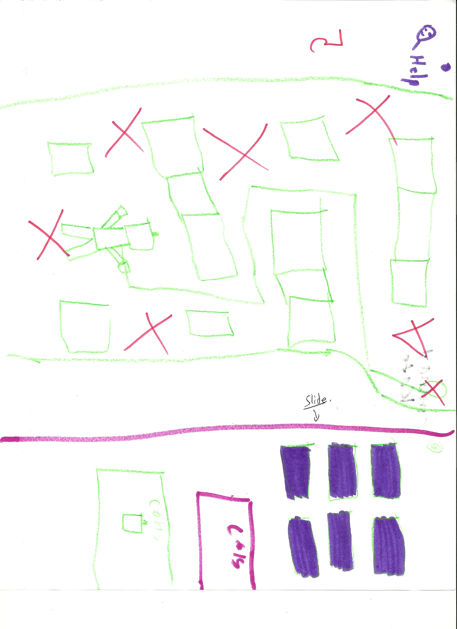

Figure . – Example of drawing from Kidsteam Session 1

The analysis was conducted in three parts. First, while the design ideas were being presented, a researcher asked questions and wrote everything that was described on a whiteboard. After all the teams had presented, five researchers and the children talked about overarching themes and marked the whiteboard with the “big ideas”. Second, shortly after the session was completed, the researchers debriefed while analyzing their observations (written or verbal) and discussed their ideas and how they relate to each other and the process. Last, the artefacts were collected (e.g., notes from the researchers, drawings and pictures) and analyzed and coded by one researcher using open coding principles [32, 33].

When answering the question “what does the word programming make you think about,” it became clear that all the children knew it related to technology and/or video games. That said, most did not have a clear understanding of why programming exists. The robot activity indicated that the children may have lacked a clear understanding of what programming is, since they could not disassociate it from the robot or make any inferences about other areas to which it would apply. However, they had (or quickly gained) a rudimentary understanding of the concepts of syntax, semantics, iteration, parameter passing, and compound procedures [3] after they were shortly explained to them. Even though the children were prompted to n during the drawing phase, the prototypes that they designed revolved around robots. We believe that this fact implies that they associate programming with technology and machines and that they liked robots, but not that they did not grasp the concept of programming.

As far as game mechanics were concerned, separate levels and modules were present in all of the group designs (as opposed to a sandbox world or other game mechanics). The levels did not only signify progression in the game, but also difficulty (e.g., commands like turn clockwise might not be understood by all young children). All groups included an element of collecting items in their design, as well as obstacles and/or traps. Another overarching theme was development i.e., upgrading and customizing your robot (or possibly other character). Furthermore, castles, mazes, and teleporting were mentioned often, while other ideas included dodgeball and racing. An interesting observation was that all of the teams had draggable interface elements. Finally, keeping in mind that they were designing an application for children that cannot read, most of the teams focused on large pictures on buttons and/or reading things out loud multiple times for the user.

### Effect on the design

After the data was analyzed, a researcher designed the first wireframe of the application using the results from this session. This wireframe was heavily based on this data in multiple ways: Robots are a major concept in the game, while a castle defines the environment of the world and different creative tasks are involved such as climbing stairs or playing dodgeball. The maze (levels 1-3) is important in understanding the basics of programming and was mentioned frequently during the Kidsteam session. Furthermore, the robots and the castle are customizable and upgradable (with progress in the game) since each group’s designs included these elements. The design (See Appendix 1) is simplistic and not overly colorful so as to allow for brainstorming during the next Kidsteam session, which will be centered on the method of layered elaboration [16], in which the initial design should not be too complex.

## Kidsteam Design Session 2: Layered elaboration

The second Kidsteam design session brought back the initial wireframe for rapid iteration and evaluation with the adults and children that participated in the first session by using the technique layered elaboration [16]. Layered elaboration is a participatory design technique that generates ideas in an iterative manner. In this technique, groups of 2-3 children and 1-2 adults draw separately on a “page” of a design and then they rotate; this results in the children drawing on top of each other thus elaborating on each other’s ideas. The goal of this session was to iterate on the initial wireframe design using feedback from a design team that includes experienced participatory designers close to the target user age. Since the children are not confident with CT and programming concepts, this session did not aim to examine how they would want to learn them. The wireframe now contained 7 pages that were mainly black and white and not crowded with content, which is suggested for this technique in order to get a high level of input from the children [16]. The pages consisted of 5 levels of progressing difficulty, a ‘castle’ that they own and can customize, as well as a ‘shop’ where they are able to buy parts for a ‘robot’ character that belongs to them and their castle.

As in the first session, the participants were asked to answer a ‘question of the day’, which in this instance was “tell us about a time when you gave instructions to someone”. The goal of this question was to indirectly reintroduce the concept of programming to the children, and to observe once more how they think about instructions.

We then showed and explained each ‘page’ of the wireframe to the children. This step was important because a lot of the interactions that were part of the design were not visible on the wireframes. These interactions included animations that would demonstrate how to perform a certain gesture to achieve a certain task, sounds, and automated prompts that would help users understand the goal of each level. The children were split into groups and asked to draw things that they want to add or change, make suggestions on how the auditory instructions would work and how they would be phrased, as well as find their own ways to help the young children understand the goal of each ‘page’.

The layered elaboration part of this session consisted of rotations of all the designs within the groups. During each rotation, each group was given a page with a transparent sheet on top and permanent markers to draw with. The researchers participating in this session were asked to take extensive notes about the children’s ideas and quotations. The groups had 3 minutes to elaborate on each design, after which a ‘standup’ meeting took place where each group was given 1 minute to explain what they did and why. Subsequently, each group was given another design to elaborate on, often one that had already been augmented by another group, with a second transparency on top, so that the groups’ individual designs were not distorted (Figure 6.2).

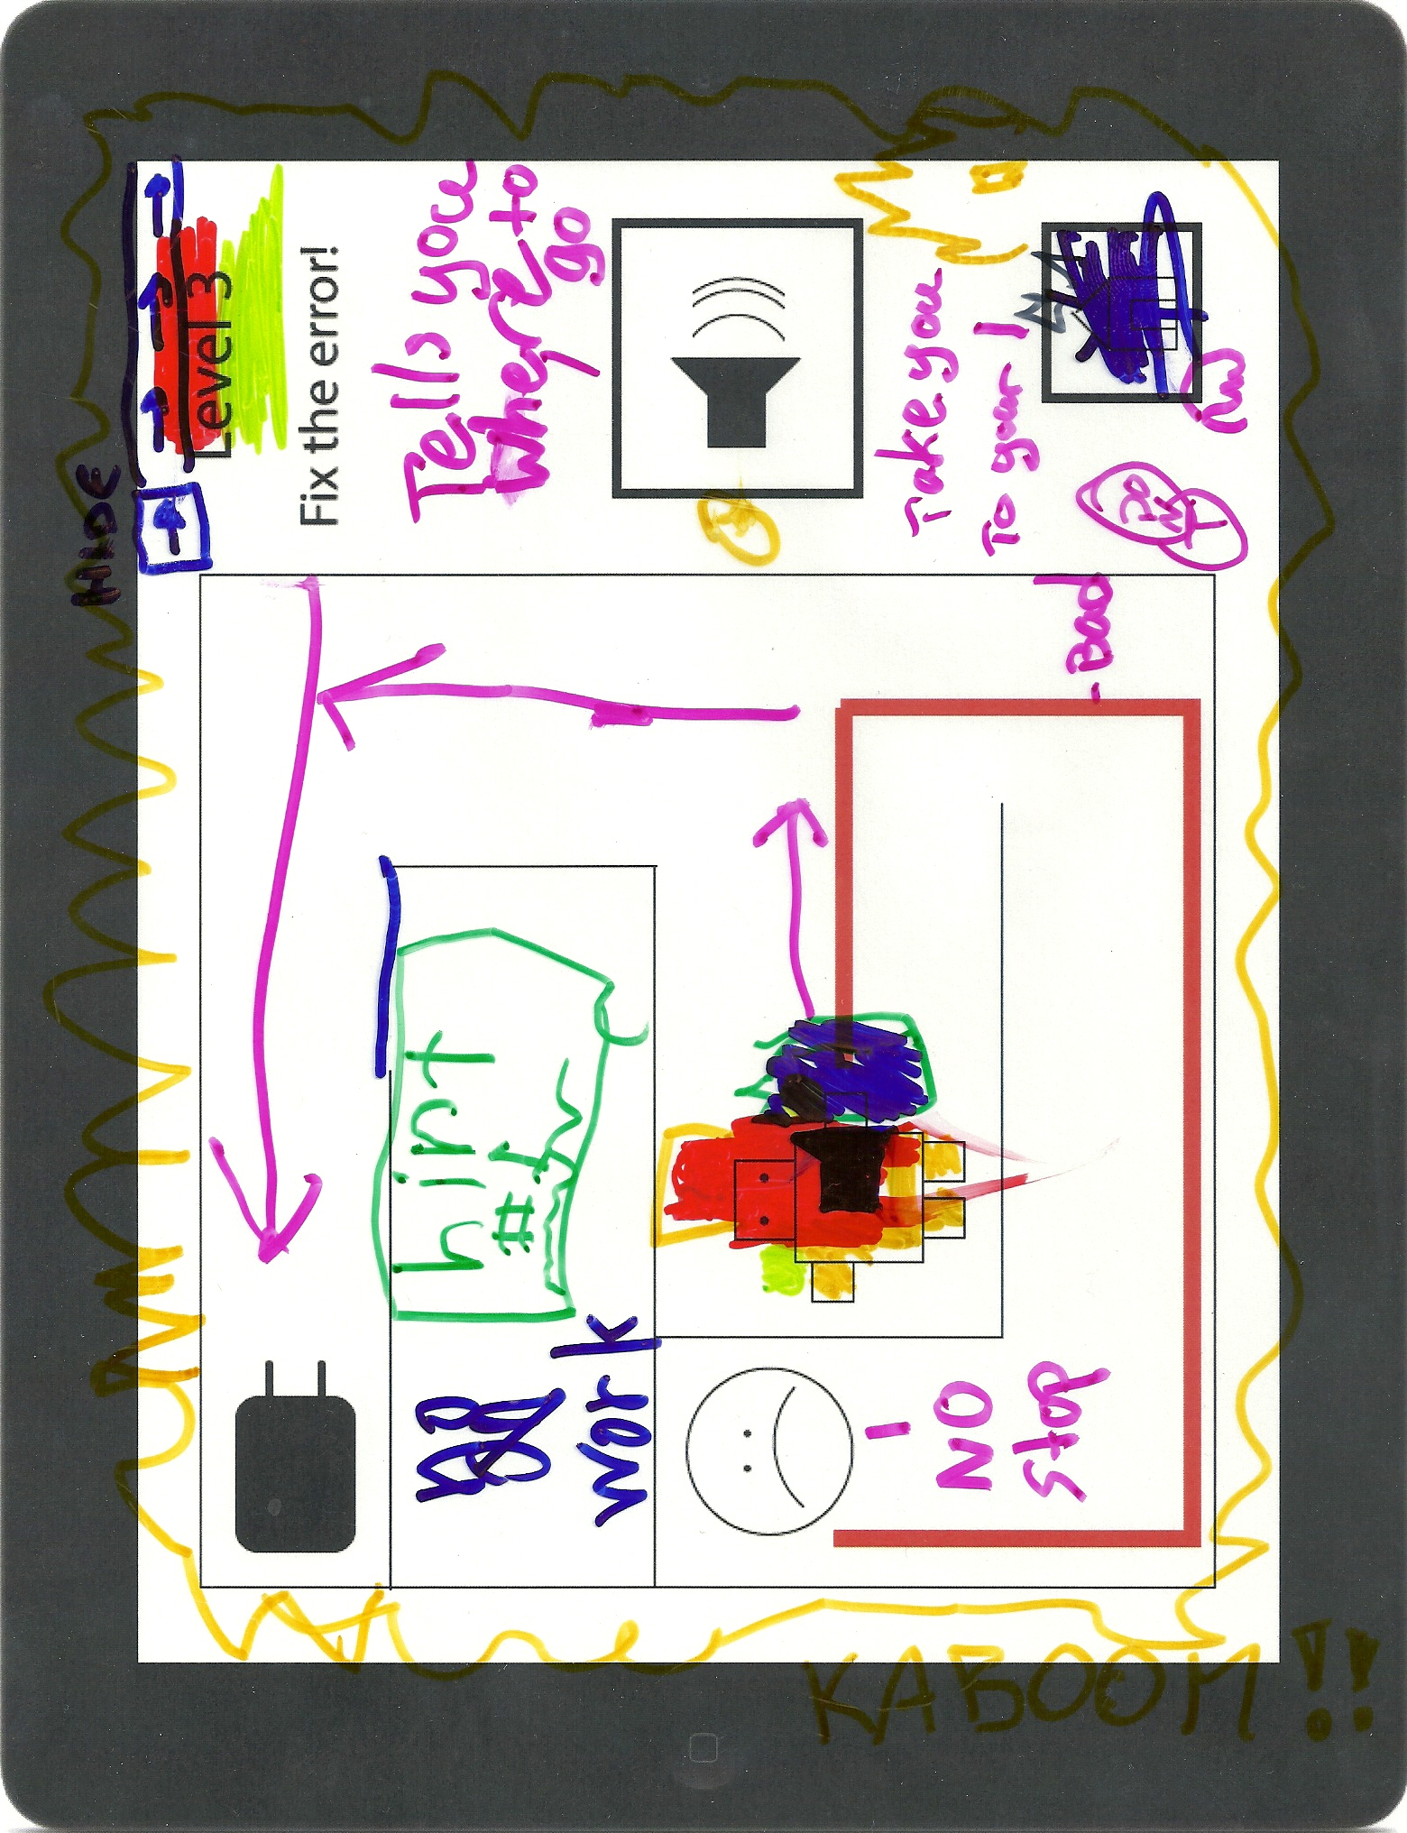

Figure . – Layered elaboration design

A debrief meeting took place a few minutes after the children had left, where each researcher presented their observations, comments, and advice. The researchers also talked about overarching themes that they observed, which were written on a whiteboard and discussed extensively. Later in the day, the designs and the notes written by the researchers were scanned, transcribed (where applicable) and analyzed by one researcher in an attempt to extract more overarching themes, as well as specific design changes and additions for each level and the overall structure of the game. The interpretation of the notes was conducted through loose frequency analysis, whereas the designs were used to find areas of the interface that drew a lot of attention (were drawn on more than others) and to observe how certain ideas were implemented.

When asked to think of a time when they were given instructions, two of the children instantly mentioned the previous Kidsteam session, where they were programming the researcher acting as a robot. This suggests that the robot activity in Session 1 functioned in a desirable manner, in that the children connected the concept programming to that of giving instructions. Interestingly, two children also mentioned teaching their pets how to perform certain complicated tasks. One child mentioned that he gave his parents explicit instructions on how to help him get off his bed when he was injured.

An idea that was uniformly embraced by all children in the groups was that of including animals in the game and giving them functions. The designs also suggested that the children want surprises like bursts and explosions. The element of customizability also emerged as the children expressed desire to color their robots or adjust the game to their playing style. Furthermore, the children had a strong desire to interact with the robot on a personal level; the robot would provide them with instructions, praise and positive feedback. Last, they requested that limited “easy ways out” be given to them, in case they got stuck on a specific level.

### Effect on the design

The second iteration of the design (See Appendix 2) was heavily informed by the Kidsteam Session as most additions were based almost exclusively on the elaboration of the ideas that the kids designed during the session: The children explicitly mentioned that they wanted the robot to talk to them directly, but they did not want the narrator to go away, which is why two different voices were implemented. Furthermore, if the player fails to succeed for 7 consecutive times, an animation pops up showing what needs to be done for each specific level. Some stylistic changes were also based on feedback for the children, e.g. the home button now looks like a castle with a “C”. This session introduced the concept of currency in the form of stars that are collected, and the concept of buying upgrades. Animals were also added to the game, as upgrades for the robot, but also as part of the grid in level 4.

## Formative evaluation with experts (Teachers)

In order to acquire feedback from experts of a different field (that of youth education), we conducted two 30 minute semi open-ended interview sessions with a pair of teachers (recruited from the CYC). The first pair of teachers interviewed taught three and four year olds, while the second pair taught five year olds. All four teachers have been in the profession for three to five years, and they have all worked with iPads in the classroom for about six months. The goal of this session was to gain information on two levels: the quality of the interactions and the quality of the learning. The perspective of educators with experience working with touch screen devices is especially valuable since it provides insight on how children of ages 3-5 interact with them. We chose to interview the teachers in groups of two to allow for group discussion and support elaboration on ideas in a way that we considered a more productive type of feedback. Each session began by giving the teachers one iPad with the application (after explaining its goal) and asking them to provide us with feedback on how the children would respond. We were interested in answering the following questions:

* What aspects of the application are age appropriate and what are not?
* How can we improve the usability, learning potential and fun of the application?
* What types of challenges would we expect in terms of learning?
* How would the technology support or hinder the children in their learning?
* What are the determining factors for whether they would use it in a classroom?
* How would they use it in a classroom? Would it be a guided or an independent activity?

Since the interviews were open ended, the teachers were also asked to provide us with any other type of feedback they felt would benefit us. The sessions were not recorded, but the researchers present took hand-written notes with observations, quotes and comments. After the sessions were completed, debriefing took place and the researchers observed themes on the notes through an informal frequency analysis.

One of the most interesting findings from this session was that the teachers working with 3 and 4 year olds had sharply different answers to our questions from those working with 5 year olds, which is why we are presenting the results separately.

### Teachers of 3 and 4 year olds

In terms of age appropriateness, the teachers felt that most of the content on the application was at the right level. It would aid the children in developing hand-eye coordination, as well as with their problem solving capabilities. In terms of learning, the teachers mentioned that they would prefer a smoother transition between the levels, as well as the ability to replay the levels multiple times since repetition helps children learn and understand concepts much better. They found that Level 4 contained too many components that 3 year olds would have trouble with, like understanding spatial directions and processing more than 3 instructions at once (this level requires 6). A possible solution that they suggested for this problem was to add a duplicate of this level before it, with the only difference being that the robot moves immediately after receiving one command (instead of waiting for the whole list).

As far as the interactions are concerned, they felt that the majority of them were at the right level for the target age group. However, they mentioned that tracing a line might be difficult for some 3 year olds, although that is countered by the fact that they do not need to trace any specific line, but draw a freeform one – as opposed to a letter tracing game that they are currently using in the classroom. They also believed that the children would need to be told explicitly what the buttons are and why they would click them, because they would be distracting. Finally, they suggested only allowing them to visit the castle in certain times.

Overall, the teachers felt that the application would support the children in their learning, especially if the activity is repeated multiple times. They mentioned that they are not certain the children would understand the difference between “replaying” and “running a program”, but we do not consider the semantic distinction between the two terms obstructive to the fundamental understanding of the concept of compound procedures, as the conceptual root is that the instructions they gave once will have exactly the same effect under the same conditions. Furthermore, the basis for this concept (i.e. showing that a larger “action” can consist of smaller ones [3]) remains unobstructed since the entire series of actions is clearly portrayed as “one level” and one action “in the form of a button”. Last, the teachers strongly believed that the children would find the application engaging and fun.

When asked whether they would use it in a classroom, they said they would not because it does not look like it would fit the curriculum that they are assigned to follow. They also mentioned that they currently only use iPads for one type of activity (letter tracing) and that they cannot fully integrate them into their everyday activities, especially because they would not know how to assess them on it. The teachers proceeded to provide us with their curriculum in order to study it and determine what aspects of it might fit with adjustments. Finally, when asked how they would use the application in a classroom, they mentioned that due to the way children of ages 3 to 4 think, it is difficult for them to participate in an independent activity, since they need to know what the application, teachers and parents are expecting from them; these expectations need to be predefined explicitly and elaborately. Therefore, they would use this application only in the form of a guided activity, where at each stage an adult would be present to tell them exactly what they need to do and why, what is expected of them and give them instructions (even if the instructions are just the equivalent of “Listen to the instructions that the robot is giving you”).

### Teachers of 5 year olds

The second group of teachers also found the application to be fitting in terms of age appropriateness. They also mentioned that the problem solving capabilities of the application are worthwhile and they did not find anything that was too advanced for 5 year olds. On the contrary, they believed that it required the right amount of logic and problem solving skills. In terms of learning, this group of teachers also mentioned that they would like a smoother transition between the different levels so as to allow for repetition of similar tasks while introducing at most one new small concept at a time. Last, they suggested the same thing the first group of teachers suggested for level 4, i.e. to add a duplicate before it that allows for instructions to be executed on button press.

In terms of interaction, as with the first group of teachers, they believed that the majority of interactions were appropriate, but they felt that it would be useful to demonstrate each level to the children before asking them to do it, especially when introducing a new goal or type of interaction in order to not confuse them. They mentioned that they would like the flow of the application to be slightly faster and that they would like more graphics to be present. Furthermore, they felt that the majority of the audio in the application, while of good quality, takes too much time and might allow for distractions that could harm the learning.

Overall, they considered the application to be of high quality and mentioned that the children would particularly enjoy the voices and the pictures, as well as the reward system and the castle, and they mentioned that the choice of “charging” as an activity is appropriate for this generation of children, since it is something that directly relates to their everyday lives. They also mentioned that the way the vocabulary was being presented to the children was age appropriate, and they would like to see the terms spelled out for the children as well. They believe the children would like to see some more “extras”, like being able to visit the insides of your castle, or buy things for your garden.

In contrast with the first group of teachers, the second group explained that they would definitely use the application in the classroom. More specifically, they would use it as an independent activity since they did not find it to have content that the children would fail to understand by themselves, especially if the instructions are slightly more elaborate. Since helping 5 year olds be independent is one of the goals that the teachers have in the curriculum, they would use this application for this purpose and to provide them with problem solving and reading opportunities. Furthermore, they mentioned that they might use it in an activity where the children would work in pairs, since they could help each other fill in possible gaps in comprehension of the goals and mechanics of the application, as well as motivate them. Last, the teachers mentioned that this application, if expanded properly could be beneficial for children up to 7 years old.

### Lessons Learned

These two sessions provided valuable feedback that directly translates into practical guidelines that can be used when designing such an application. More specifically, they showed us that there is a vast difference between how 3 and 4, and 5 year old children would interact with the application. When the users of the application are younger than 5, the teachers suggested guided activities, where an instructor helps clarify what is expected of them. Furthermore, the design of such an application needs to take into account possible motor control difficulties that children of that age have. On the contrary, such an application needs to take into account that a more independent exploration may be appropriate for older children (5 or older), who do not require an instructor to be present.

Regardless of the users’ ages, the application needs to provide them with the opportunity to repeat the exact same activities, while gradually providing them with tasks and levels that are more demanding. Further, real life examples help the children understand used as analogies to the concepts being learned. Moreover, the teachers suggested not including difficult concepts that are unrelated to programming (e.g., children of that age have trouble with spatial directions). Last, words that the children are not familiar with should only be presented to them after the concept has been explained; for example, it would be a good idea to let the children complete an activity before telling them that what they did is called debugging and elaborating on the concept.

## Formative Evaluation with young children

After implementing the product, we conducted three 25 minute sessions with two target users each (6 children total); the children were from two different classes at the CYC. The first session was conducted with a 3 year old girl and a 5 year old boy, and both subsequent sessions included two 4 year old girls. While three of the children had iPads at home, they were restricted to “bed-time TV” or rarely for games. The other three children only used iPads at the CYC in the context of their activities. As the teachers suggested, we chose to conduct the sessions with two children simultaneously; allowing them to help and motivate one another. The goal of these formative evaluation sessions was to ascertain how target users would respond, as well as determine possible differences between 3, 4, and 5 year olds. More specifically, we were interested in answering the following questions mainly through observation, but also through direct feedback from the children:

* What areas are the children having trouble with (and why)?
* Do they understand the interface as well as the concepts well?
* Do they like the application and its interactions?
* How can we improve the usability, the learning interactions and the fun?
* What challenges might the children face?

Each session began with the researcher introducing himself, followed by a short explanation of the activity and their right to stop at any time. Afterwards, the children played with the application while the researcher occasionally provided guidance (i.e, telling them what to do next or helping them if they were having trouble). Throughout the session, the researcher asked questions to clarify that the children understood what they were doing; for example asking them to explain what they did, or by asking context specific questions like “Why did the robot move there.” Whenever the children expressed an opinion or provided feedback, the researcher attempted to help them elaborate on it and perhaps suggest how to improve it. At the end of the session, the children were prompted to rate how much they liked the application using a 5-likert scale with smiley faces (the Smileyometer [34]) and also to suggest improvements. The collected data consisted of the researchers' written notes and observations.

Overall, the application was very appealing to all children. Most of the feedback that we received from the two pairs of teachers was reflected clearly throughout all sessions. More specifically, the majority of the comments of the first pair of teachers applied to what was observed in the way the 3 year old girl was using the application, whereas most of what the second pair of teachers said was apparent in the behavior of the 5 year old boy.

The four 4 year old girls reflected data from both sessions with the teachers at different times. The 3 year old girl, as well as one of the 4 year old girls, experienced difficulty drawing a line. Their fingers often lost contact with the iPad, with unwanted results, something that the 5 year old boy did not face issues with. However this did not cause frustration to the girls, given that they were able to complete all of the tasks. Another interesting observation was that all of the 3 and 4 year old children had trouble with starting the drawn lines on the robot (they started next to it instead), which resulted in ostensible unresponsiveness. While the 5 year old boy mostly interacted with the iPad independently, the 3 and a 4 year old girls sought instructions multiple times on each level (“What do I do now?”). The girls sought instructions in a manner similar to what the teachers predicted. The researcher’s observations suggest that these girls did not attempt to understand the application independently, rather they expected explicit instructions from the adult researcher. The 5 year old child, on the other hand, reached the last level of the game before asking for help.

The difficulty of the content and the concepts of each level seemed age appropriate for all children; with the exception of level 4, which only the 5 year old boy understood. Although the boy initially failed to complete level 4, he was able to explain what was happening when asked after the level was demonstrated to him. The other children, however, could neither recreate the result nor explain the cause and effect.

None of the children clicked any of the buttons on the side without being prompted by the researcher. Similarly, when they went to the castle, the researcher had to explain what the castle was and how it worked due to insufficient instructions. However, once the children understood how the castle and the stars worked, they constantly wanted to go back to the castle and buy more things. They seemed to really enjoy both the concept and the artwork. All children, especially the 3 year old girl, often ignored verbal instructions because they were depending on the researcher to answer any question that they might have.

One of the most interesting observations was that five out of the six children wanted to replay the game after they were done. After the children finished the game, in typically less than 5 minutes, they wanted to replay it immediately and were excited to do so. This occurred multiple times, which is why each child played the game at least three to six times. Even after their last time, the children wanted to play the game again, but there was no time left. When asked why they wanted to replay the game, they said they wanted to “get more stars so they can buy more things for their castle”. This indicates that collecting stars and buying objects for their castle became their motivation even though they were never explicitly told they needed to collect stars or to improve the castle and robot.

On the whole, four of the six children seemed excited and engaged, as they were not once distracted by their surroundings. Similarly, the robot voices made them laugh and they seemed to enjoy the visuals. During the session with the 3 year old girl, she looked like she was getting bored of the application; however, she explicitly asked to keep on playing with it. When the children were asked to rate the application based on how much they liked it using the Smileyometer, 6 out of 6 children immediately gave it a 5/5 (i.e., the face with the widest smile). Finally, as far as direct feedback and suggestions are concerned, it proved difficult to keep some of the younger children engaged and help them express what they would want. However, the 5 year old boy explicitly said that he wanted the introductory level to have stars, more levels, and the ability to replay the levels.

# Discussion

The field of computer science is one of great importance. There is great need for more computer scientists especially from diverse backgrounds, which is proven by the extensive discussion within the field regarding how to bring more diverse people into the industry [25, 11, 12, 15]. One feasible way to achieve this goal would be to expose children to gaming or programming-like content [11, 13]. To that end, this project sought to create a touch-screen application that would aid children in acquiring skills that are fundamental to programming.

This project has demonstrated that the task of creating such content for young children is achievable. The design of the application has benefited from the involvement of children at all levels of the design process. With proper scaffolding, children as young as three years old were not only able to perform programming related tasks, but they enjoyed doing so. If such an application succeeds in helping scaffold the learning of programming skills, the children will benefit from it in terms of early development.

While the data is not indicative of the children’s growth in skills fundamental to programming, this project contributes to the body of knowledge that future researchers can use to develop new applications for children. Furthermore, if products such as these became widely available, more people may be drawn into the field of computer science [11, 13]. Increased interest in computer science can help diversify the field and contribute to its evolution [12, 15, 8]. Finally, an interesting topic to consider is how such an application could connect to the objectives of a school curriculum, or how it might be used in the context of a family.

# Limitations

Given the limited time and resources available, the last step in our research was a formative evaluation. Furthermore, to stabilize and evaluate a more mature version of the product, it would have to be iterated on two or three more times and a non-formative evaluation would have to be conducted. As it is, it is difficult to safely say that the application successfully helps children develop programming skills. To fully establish whether the application actually succeeds in scaffolding the learning, it would require a long term case study to be conducted, which was beyond the scope of this capstone project. Another limitation was that the levels proved to have moved too quickly from one concept to the next which confused the children; the sessions could have potentially provided us with more detailed results if the transition between the levels was smoother in terms of the concepts introduced.

Particularly in the case of level 4, which was the level closest related to programming, none of the children were able to complete it. However, as the teachers suggested, the problems with this level were not related to the concept we were trying to convey, more so the fact that we required planning of 6 separate spatial directions at a time. In order to address this problem, this level would have to be redesigned so as to only require a total of 3 commands. Also, the previous level should demonstrate the interaction with the robot excluding the concept of planning, i.e. the robot would move directly after pressing each button. Thus, as the teachers suggested, the children would understand the concept without the notion of planning first and would be able to move on to planning 3 steps ahead much faster.

Furthermore, the application only delved into few concepts (mentioned earlier) and provided few levels for the children; the short duration of the game combined with the inability to play the same level again proved to be an important obstacle, since all of the children asked to replay at least one of the levels. In order for the program to be finalized, more levels would be required, and a more structured reward system developed, to allow for longer play-time, as well as to encourage players to return to the application. Last, since none of the researchers were experts in teaching CT or programming concepts, the project lacked a structured way of deciding how, when and in what order to appropriately convey them to the children.

# Future Work

In terms of changes to the application, a most notable one would be to allow for adjustments based on the age of the participant. The sessions with the teachers, the children, as well as the literature suggest that the differences between a 3 year old, a 4 year old and a 5 year old are vast. More specifically, there should be four categories (3 years old, 4 years old, 5 years old and older than 5). This would involve not only adapting the interactions themselves (e.g. drawing would be made easier for 3 year olds), but also providing age appropriate concepts. Further, various adjustments would need to be made to enhance the usability of the game as well as the instructions based on the feedback from the teachers and children (e.g. less delay, making level 4 simpler etc.). Last, one important addition would be the ability to repeat levels and expand on them, since this was not only something the teachers said, but it was also obvious that they children desired to replay it.

For all of these changes to be carefully studied and decided, more formative evaluation would have to be conducted with the target users that would be aiming to answer more specific usability or learning related questions. The teachers’ different views on how the application should be used demonstrated that it would be beneficial to design for both independent and guided usage, while perhaps considering the suggestions of Lin and Liu [1]. The application could further be adjusted so that it can adapt better to the curriculum of preschools.

Since the field of programming related touch screen applications for children is extremely new and unexplored, future work should also involve conducting research with the exclusive goal of providing guidelines for such a game or application. This research should be split into two different parts. The first part studying the types of interactions that are appropriate, including instructions, game mechanics and information architecture. The second part would study in depth which programming related concepts are appropriate for which ages, and how best to convey them through the touch screen application.

Our research could be further expanded through focus on the assessment of the educational outcomes of the application. This could be implemented either in a short term or in a long term manner. A carefully designed pre and post-test experiment would allow us to examine whether children were able to complete certain tasks easier and whether they had a deeper understanding of the concepts after having used the application. A long term case study, through the course of a few months, on the other hand, would allow for more results on how prolonged use of application enhanced the children’s understanding of the concepts it is attempting to elaborate on. Last, in order to gain a holistic view on the educational processes involved, it would be beneficial to research how the concepts being examined by our application slowly evolve into a complete understanding of programming and CT concepts. A possible way of achieving that would be to expand the application to target children of older ages, while slowly introducing more complicated concepts. This could allow us to examine how the concepts are transformed from their rudimentary forms to their full extent.

# Conclusion

Children of ages as young as 3 years old can start developing skills that will later on support them in learning how to program and provide them with a good base for CT [2]. In the process of conducting this research we created an application that attempts to address this void in the knowledge community. The data collected from sessions with teachers of young children, as well as from the sessions with children of ages 3-5 converges to the same conclusion: Children of that age want to program [26], and they certainly enjoy doing it on a touch screen application. The application that was built in the context of this research could be expanded and used in the classroom, either independently or with teacher guidance. Furthermore, the capabilities of children that are 3 years old are vastly different from those that are 5. Hence, there are design implications that need to be carefully considered when designing such an application, instructions need to be given at all times through multiple means such as audio, video, pictures and text and expectations need to be managed.

# Acknowledgements

Special thanks to Mona Leigh Guha and Tamara Clegg for forming this research, actively participating, providing extremely valuable help, and supporting me throughout the entire process of conducting this research. I would also like to thank Leah Findlater for her valuable feedback and guidance, as well as Kidsteam, the Center for Young children faculty, staff and children, as well as my classmates and all the people that participate in the Human-Computer Interaction lab for their support and guidance.

# References

|  |  |
| --- | --- |
| [1] | J. M.-C. Lin and S.-F. Liu, "An Investigation into Parent-Child Collaboration in Learning Computer Programming," *Educational Technology & Society,* vol. 15, pp. 162 - 173, 2012. |
| [2] | J. Montemayor, *Physical programming: tools for kindergarten children to author physical interactive environments,* University of Maryland, College Park, MD, USA: Thesis, 2003. |
| [3] | L. Morgado, M. Cruz and K. Kahn, "Preschool Cookbook of Computer Programming Topics," *Australasian Journal of Educational Technology,* vol. 26, no. 3, 2010. |
| [4] | R. Sheehan, D. Cho and J. H. Park, "Improving on a physics-based programming system for children," in *Proceedings of IDC 12*, Bremen, Germany, 2012. |
| [5] | T. Y. Lee, M. L. Mauriello, J. Ingraham, A. Sopan, J. Ahn and B. B. Bederson, "CTArcade: learning computational thinking while training virtual characters through game play," in *Proceedings of CHI EA 12*, Austin, TX, USA, 2012. |
| [6] | A. Sipitakiat and N. Nusen, "Robo-Blocks: designing debugging abilities in a tangible programming system for early primary school children," in *Proceedings of IDC 12*, Bremen, Germany, 2012. |
| [7] | S. Papert, Mindstorms: children, computers, and powerful ideas, New York, NY, USA: Basic Books, Inc, 1980. |
| [8] | J. Goode and J. Margolis, "Exploring Computer Science: A Case Study of School Reform," *ACM Transactions on Computing Education (TOCE),* vol. 11, no. 2, 2011. |
| [9] | K. Kahn, "Generalizing by removing detail: how any program can be created by working with examples," in *Your wish is my command*, San Francisco, CA, USA, Morgan Kaufmann Publishers Inc., 2001, p. 21–43. |
| [10] | A. Druin, "Cooperative inquiry: developing new technologies for children with children," in *Proceedings of CHI 99*, Pittsburgh, PA, USA, 1999. |
| [11] | B. J. DiSalvo and A. Bruckman, "Questioning video games' influence on CS interest," in *Proceedings of FDG 09*, Port Canaveral, Florida, USA, 2009. |
| [12] | A. Fisher and J. Margolis, "Unlocking the clubhouse: the Carnegie Mellon experience," *ACM SIGCSE Bulletin,* vol. 34, no. 2, pp. 79-83, 2002. |
| [13] | C. Kelleher, R. Pausch and S. Kiesler, "Storytelling Alice Motivates Middle School Girls to Learn," in *Proceedings of CHI 07*, San Jose, CA, 2007. |
| [14] | P. Wyeth, "How Young Children Learn to Program with Sensor, Action, and Logic Blocks," *Journal of the Learning Sciences,* vol. 17, no. 4, pp. 517-550, 2008. |
| [15] | A. Fisher and J. Margolis, "Unlocking the clubhouse: women in computing," in *Proceedings of SIGCSE 03*, Reno, NV, USA, 2003. |
| [16] | G. Walsh, A. Druin, M. L. Guha, E. Foss, E. Golub, L. Hatley, E. Bonsignore and S. Franckel, "Layered elaboration: a new technique for co-design with children," in *Proceedings of CHI 10*, Vancouver, CA, 2010. |
| [17] | A. Cypher, D. C. Halbert, D. Kurlander, H. Lieberman, D. Maulsby, B. A. Myers and A. Turransky, Watch what I do: programming by demonstration, MIT Press: Cambridge, MA, USA, 1993. |
| [18] | A. Cypher, "EAGER: programming repetitive tasks by example," in *CHI '91 Proceedings of the SIGCHI Conference on Human Factors in Computing Systems*, New Orleans, Louisiana, USA, 1991. |
| [19] | K. Kahn, "ToonTalk -- An Animated Programming Environment for Children," *The Journal of Visual Languages and Computing,* vol. 7, no. 2, 1996. |
| [20] | J. Maloney, M. Resnick, N. Rusk, B. Silverman and E. Eastmond, "The Scratch Programming Language and Environment," *ACM Transactions on Computing Education,* vol. 10, no. 4, 2010. |
| [21] | D. C. Smith, A. Cypher and L. Tesler, "Programming by example: novice programming comes of age," *Communications of the ACM,* vol. 43, no. 3, pp. 75-81, 2000. |
| [22] | A. Druin, Mobile Technology for Children: Designing for Interaction and Learning, San Fransisco, CA, USA: Morgan Kaufmann Publishers Inc, 2009. |
| [23] | L. McKnight and D. Fitton, "Touch-screen technology for children: giving the right instructions and getting the right responses," in *Proceedings of IDC 10*, Barcelona, Spain, 2010. |
| [24] | G. Revelle and E. Reardon, "Designing and testing mobile interfaces for children," in *Proceedings of IDC 09*, Como, Italy, 2009. |
| [25] | V. Barr and C. Stephenson, "Bringing computational thinking to K-12: what is Involved and what is the role of the computer science education community?," *ACM Inroads,* vol. 2, no. 1, pp. 48-54, 2011. |
| [26] | M. Kindborg and P. Sökjer, "How preschool children used a behaviour-based programming tool," in *Proceedings of IDC 07*, Aalborg, Denmark, 2007. |
| [27] | P. Wyeth and H. C. Purchase, "Tangible programming elements for young children," in *Proceedings of CHI EA 02*, Minneapolis, MN, USA, 2002. |
| [28] | P. Wyeth and H. C. Purchase, "Using developmental theories to inform the design of technology for children," in *Proceedings IDC 03*, 2003. |
| [29] | "Move the Turtle," Geek Kids, [Online]. Available: http://movetheturtle.com/. [Accessed 2013]. |
| [30] | A. Eckerdal, T. Michael and A. Berglund, "What does it take to learn 'programming thinking'," in *ICER '05 Proceedings of the first international workshop on Computing education research*. |
| [31] | M. L. Guha, A. Druin, G. Chipman, J. A. Fails, S. Simms and A. Farber, Mixing ideas: a new technique for working with young children as design partners, College Park, MD, USA: Proceedings of IDC 04, 2004. |
| [32] | J. Corbin and A. Strauss, Basics of Qualitative Research: Techniques and Procedures for Developing Grounded Theory, Sage Publications, Inc, 2007. |
| [33] | A. Strauss, "Open Coding," in *Qualitative Analysis for Social Scientists*, Cambridge University Press, 1987, pp. 28-32. |
| [34] | J. Read, S. MacFarlane and C. Casey, "Endurability, engagement and expectations: Measuring children's fun," in *Proceedings of IDC 02*, Eindhoven, Netherlands, 2002. |

# Appendix - Design 1

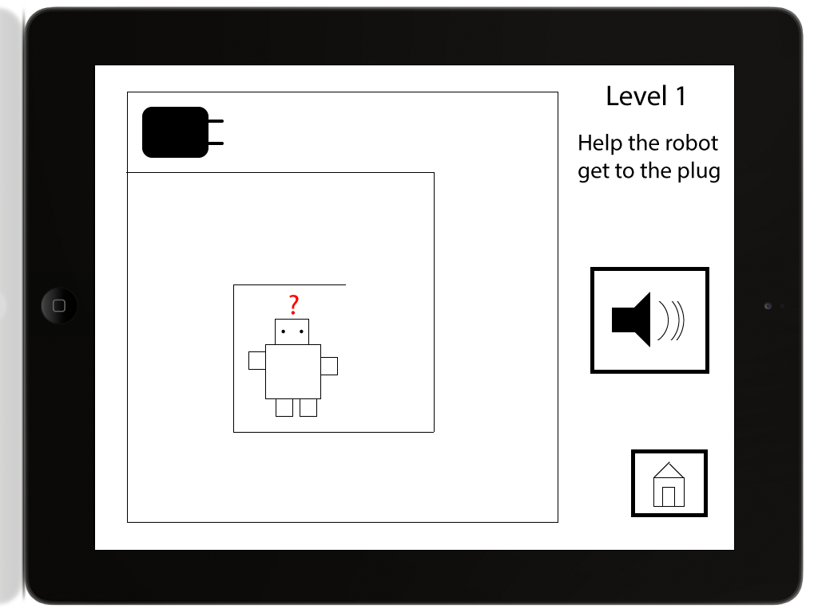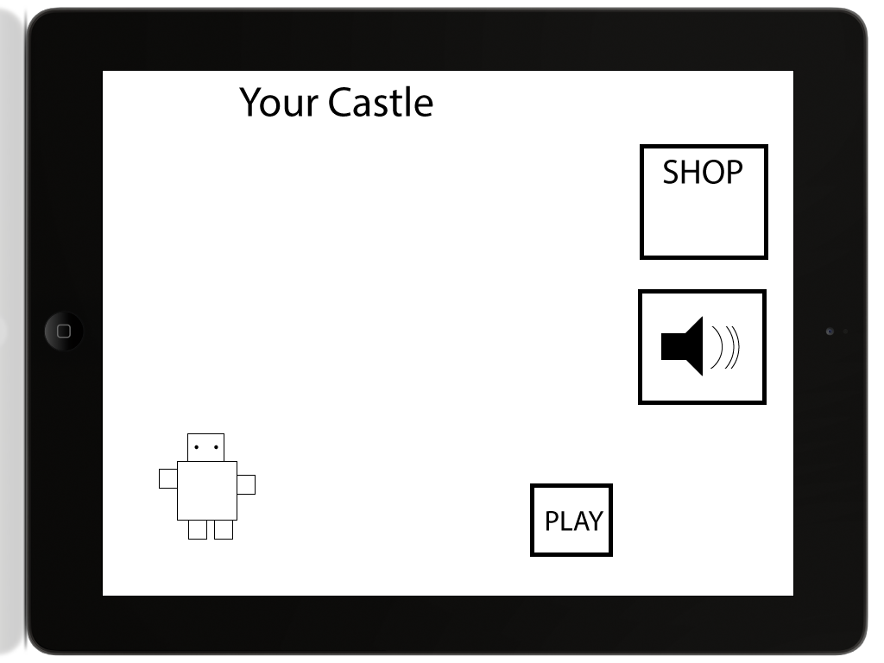

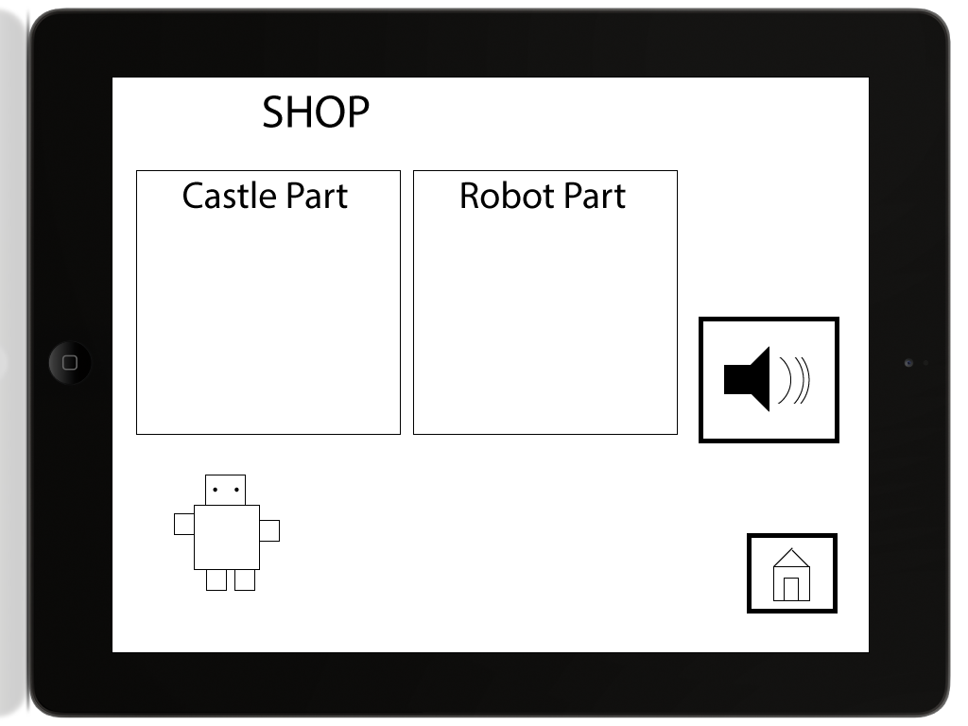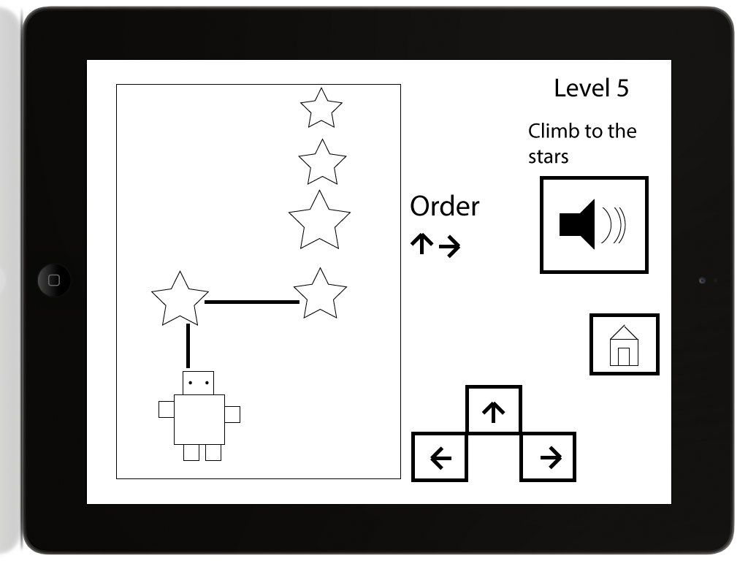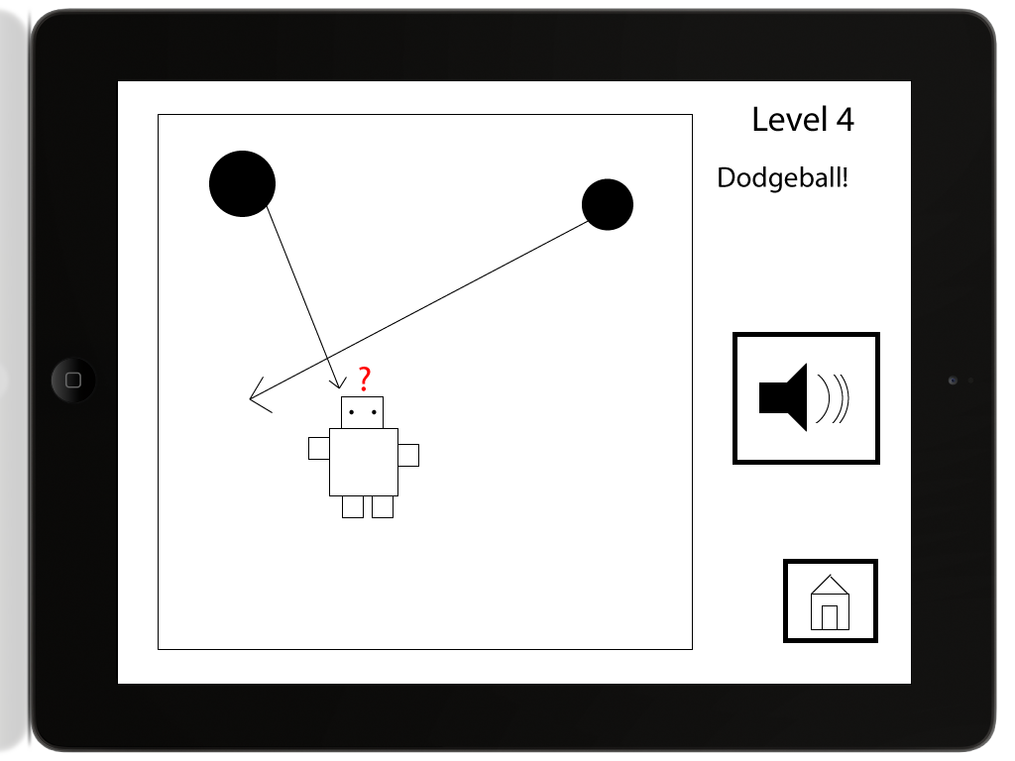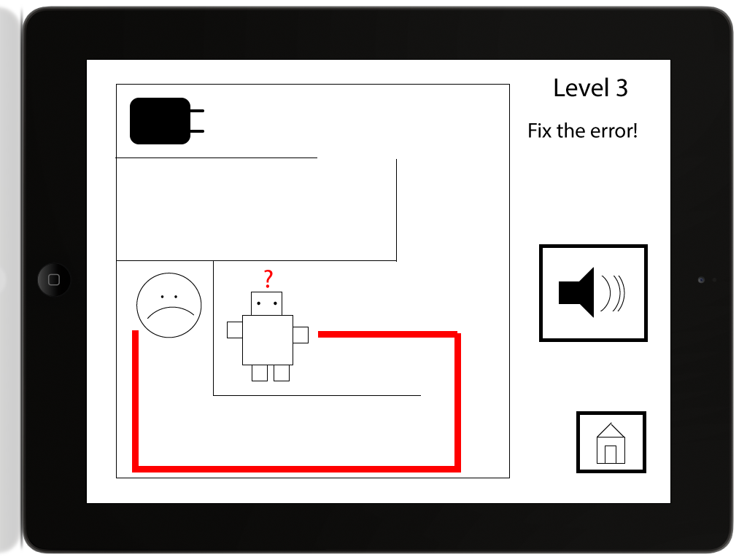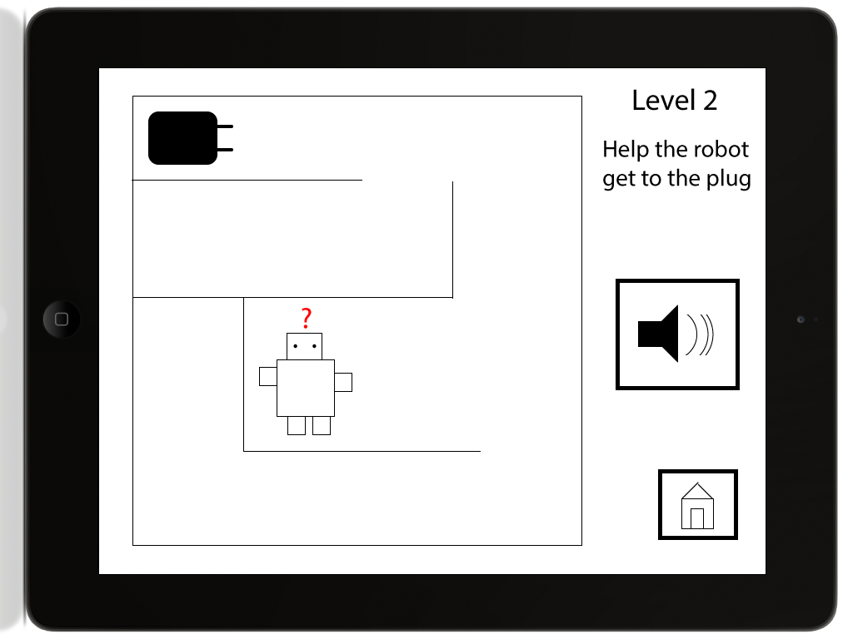

# Appendix - Design 2

